Simulator set up from the beginning.

1. IIS

Before setting up Adding Application

Check if ASP.net is installed. If it is installed then you will see it in IIS manager screen

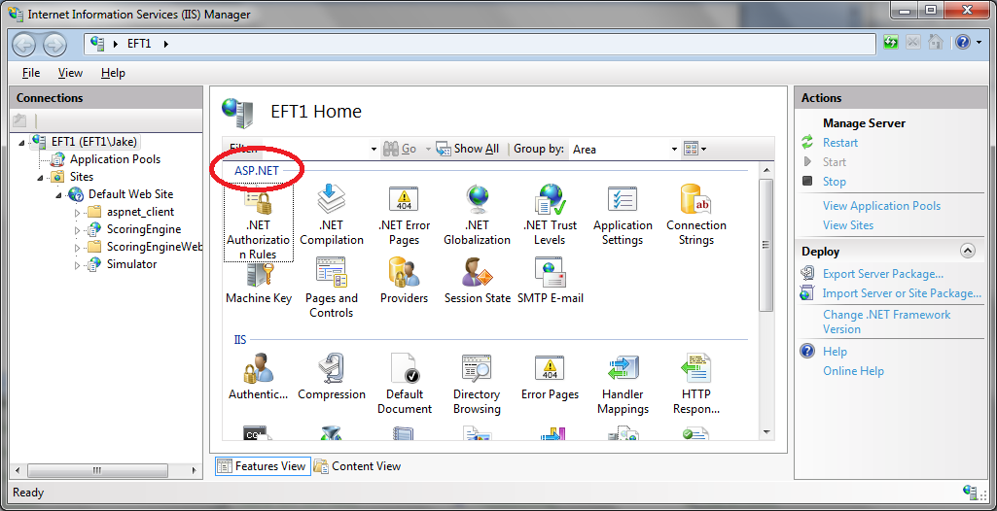

If aspnet is not installed  do:  **aspnet_regiis –I – Win 7 Pro**

2. Make sure that ASP.net is ticked when enable IIS as windows feature.

When you install IIS, but not the ASP.NET features. To check this, goto the 'Turn Windows features on or off' dialog (typing 'features' into Start Menu search will get you there) then navigate through as follows:

- Internet Information Services (IIS)  
-- World Wide Web Servies  
--- Application Development Features  
---- ASP.NET

Ensure that ASP.NET is ticked (which will probably enable a host of other features too) then try again.

**In Win server 8 –** see this link

http://developers.de/blogs/damir_dobric/archive/2009/12/04/how-to-enable-asp-net-on-winserver2008-r2.aspx

check if aspnet service running via services

It should appear in the IIS manager screen as shown above.

Right click on Application Pool, click on DefaultAppPool and AdvanceSetting:

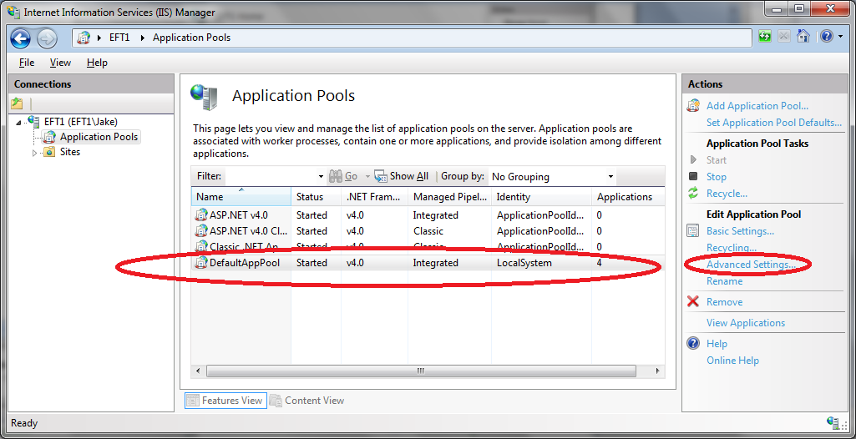

Set default pool app 32 to true and .Net Framework to v4.0

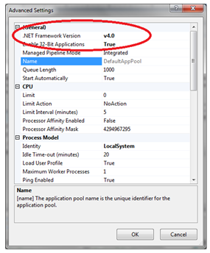

Check window install for static component. Note: this is from Win 7 Pro.

Win Server : it is under roles.

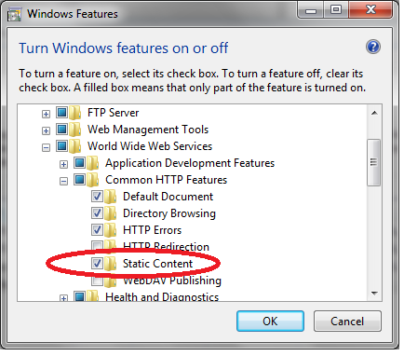

Create directories c:/simulator.

Create c:/simulator/allbin

C:/simulator/UiDir

Move our ui to UiDir

Right click on Default Web Site and choose **Add Application**

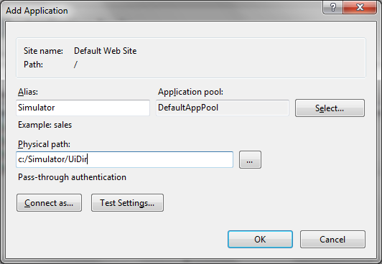

Point to UiDir dir

Make sure that all modules in UiDir are unblocked!!

Use stream.exe ( part of the package to bring over there)

Use command line switches: streams.exe –s –d “<folder path>” from dir where streams.exe is.

Maybe add user - IIS APPPOOL\DefaultAppPool and change privs to all those files?

Add user/privs to Simulator Site. Edit Permissions…

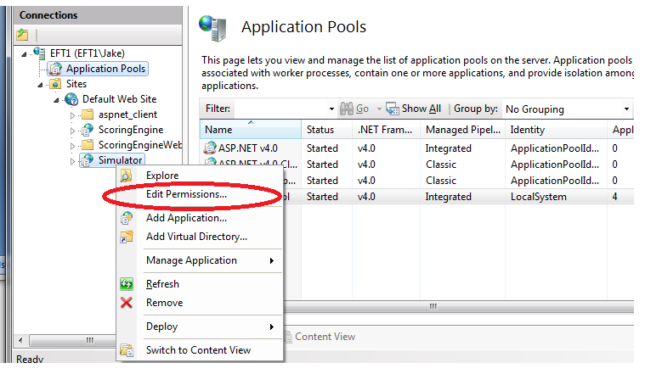

Try to bring up the site

Most likely it won't come up

Check event viewer

See the user it makes request from.

Add this user to sql user

Sql server

Make this user sysadmin in sql

Run addpriv if it has this user listed

if SQL Server is not local:

CREATE SIMDBHOST valiable and assign it to the SQL server name